CTODS Lab Viewer

caXchange - ScenPro, Inc.

Use Case Specification Document

Document Change History
Version Number | Date | Contributor | Description
1.0 | 1/25/2008 | Michael Holck & David Dorman | Initial Draft
1.1 | 2/15/2008 | Michael Holck | Reviewed and Updated


Updated February 15, 2008
Table of Contents
1. Background/Summary 1
2. Introduction 2
2.1 Document Overview 2
2.2 Related Documents 2
3. Actors and Authorization 3
3.1 Roles & Responsibilities: 3
3.2 Authorization Levels: 3
4. General Functions 4
4.1 Use Case Model 4
5. Application & Role Specific Use cases 5
5.1 CTODS Query 5
5.1.1 USE CASE DESCRIPTION 5
5.1.2 BASIC FLOW OF EVENTS: 6
5.1.3 CTODS Query Sequence Diagram 7
5.1.4 ASSUMPTIONS AND CONSTRAINTS: 8
6. System Specific Use Cases 9
6.1 CTODS Grid Services Use Case 9
6.1.1 USE CASE DESCRIPTION 9
6.1.2 BASIC FLOW OF EVENTS: 10
6.1.3 ASSUMPTIONS AND CONSTRAINTS: 13
7. Use Case Change Management & Traceability 14
7.1 Overview 14
7.2 Change Management Tracking Matrices 14
7.3 Use Case Traceability Matrices 14
8. Overall Requirements 15
8.1 CTODS Grid Services 15
8.2 CTODS Lab Viewer 15

Background/Summary
The CTODS Lab Viewer is an application that allows users to view and query lab data persisted in the CTODS Lab Domain database. This application also integrates with the other applications in the CCTS suite by sending and receiving messages from them via the caXchange Hub. In addition to the Lab Viewer there is the Cancer Center Hub Client (CCHC) application that is used to transform clinical lab data from CSV or HL7v2 format to HL7v3 and submit it to the hub for persistence in Lab Viewer. While the CCHC is not strictly a component of the Lab Viewer application itself it is the easiest way for the end user to get lab data into CTODS for display in Lab Viewer so it’s design is presented here as well.

Introduction

Document Overview
This Use Case Specification document defines the Functional Requirements for the Clinical Trial Object Data System (CTODS) Lab Viewer, version 1.0, within the context specific scenarios. The scenarios detail user defined activities required of the application and supporting systems to complete tasks and functions that are necessary to meet user occupational requirements. The scenarios are represented in step-by-step responsibility-based workflow for each actor that will use/interact with CTODS Lab Viewer.

Related Documents
Document Name | Version | Location
CTODS Lab Viewer  Technical Architecture Guide | 1.1 | https://gforge.nci.nih.gov/plugins/scmcvs/cvsweb.php/caxchange/Documentation/Design/?cvsroot=caxchange
CTODS Lab Viewer Design Document | 1.2 | https://gforge.nci.nih.gov/plugins/scmcvs/cvsweb.php/caxchange/Documentation/Design/?cvsroot=caxchange
Clinical Trial Object Data System (CTODS)  Release Notes Document | 1.1 | https://gforge.nci.nih.gov/plugins/scmcvs/cvsweb.php/caxchange/Documentation/release_notes/?cvsroot=caxchange
CTODS Lab Viewer Software Requirement Specifications Document | 1.2 | https://gforge.nci.nih.gov/plugins/scmcvs/cvsweb.php/caxchange/Deliverables/?cvsroot=caxchange
CTODS Lab Viewer End User Guide | 1.2 | https://gforge.nci.nih.gov/plugins/scmcvs/cvsweb.php/caxchange/Documentation/?cvsroot=caxchange

Actors and Authorization

Roles & Responsibilities:
Actor Actions | System Responsibilities | Dependency/Comments
C3PR User | A user of C3PR will initiate the study creation and patient registration messages
Researcher | Researchers will use the CTODS application to query lab data that has been persisted by the CTODS Grid Services

Authorization Levels:
The CTODS Lab Viewer can be configured to authenticate the users in two different ways. The first is using the Common Security Module (CSM) for performing authentication. When the Lab Viewer is installed it creates the necessary CSM schema in the database with a single valid Lab Viewer user. It also creates a valid administrator user that can use the User Provisioning Tool (UPT) that is a part of CSM to create additional users for the application. When Lab Viewer is configured to use CSM the users will be provided with a Lab Viewer specific login screen that will challenge them for their credentials and the authentication will be checked against the CSM tables in the CTODS Lab Domain database schema. The second configuration is using the caGrid WebSSO (single sign on) configuration. This configuration will redirect users who attempt to access Lab Viewer to the WebSSO login page and will put the necessary WebSSO credentials in the session and bring the user back to the Lab Viewer application. If they are configured with WebSSO then the credentials will also allow them to access other applications that are a part of the CCTS suite without re-authenticating.

Regardless of which authentication method you configure CTODS Lab Viewer to use it will still use the CSM authorization. If you are using WebSSO you will need to ensure that the same user exists in the CSM schema. The password will be ignored since it is not used for authentication however, the user id must be found so that the code can verify the user is allowed to access that application. The authentication is also managed using the UPT application that is a part of CSM. For more details on how to use UPT to configure roles and users please see the CSM documentation in GForge at

https://gforge.nci.nih.gov/docman/?group_id=12

General Functions

Use Case Model
The CTODS Lab Viewer Use Case Model identifies and describes the application’s actors, interactions with other systems, application services, and primary query function.

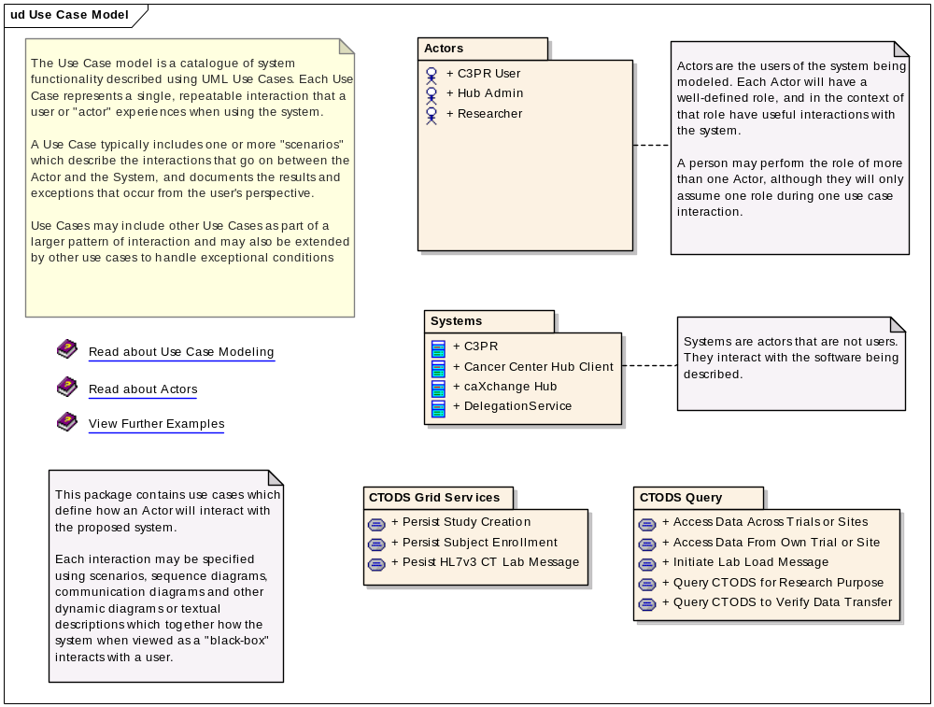
Figure 1 CTODS Lab Viewer Use Case Model

Application & Role Specific Use cases

CTODS Query
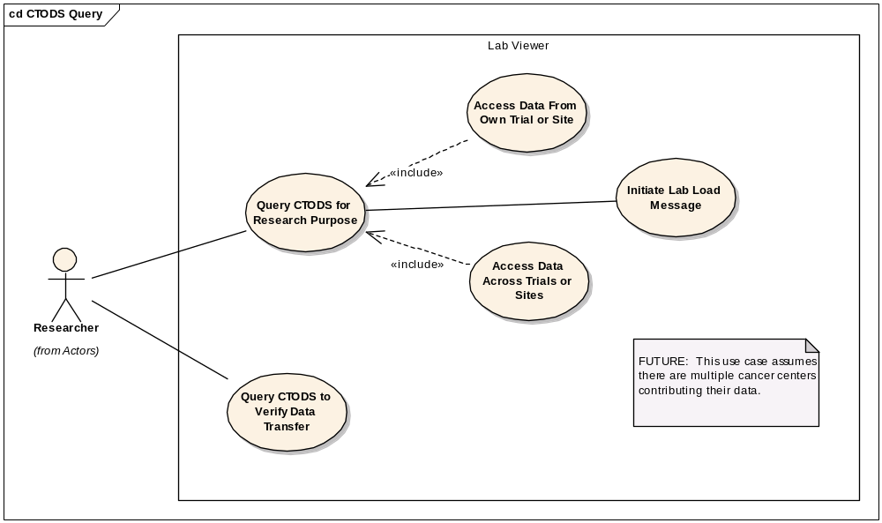
Figure 2 CTODS Query Use Case Diagram

USE CASE DESCRIPTION
Use Case Name | Grid Services
Use Case ID | CTODScaXQY_1.0
Primary Actor | - Researcher
Secondary Actor | Not Defined
Brief Description | Query data via CTODS Lab Viewer
Trigger | Actor initiated
Pre-conditions | System and supporting components are operational and available
Primary Flow of Events | - Logs into CTODS Lab Viewer  - Enters the search criteria including, study identifier, patient identifier, start date, and end date  - Results are displayed and selectable  - Records are selected  - Selected records are submitted to CTMS
Secondary Flow of Events | Not Defined
Post Conditions | The correct data is viewed and managed by authorized actors
Branch Point
Associated Quality Requirement(s)
Related Use Cases | CTODS Grid Services Use Case
Business Rules

BASIC FLOW OF EVENTS:
The user queries for lab data using CTODS Lab Viewer in the following way:
- Logs into CTODS Lab Viewer
- Enters the search criteria including, study identifier, patient identifier, start date, and end date
- The results are displayed in a table format with checkboxes for selecting specific records
- The user can select specific labs and submit them to CTMS

CTODS Query Sequence Diagram
The sequence diagram below shows the basic sequence for querying lab data from the CTODS Lab Domain database.

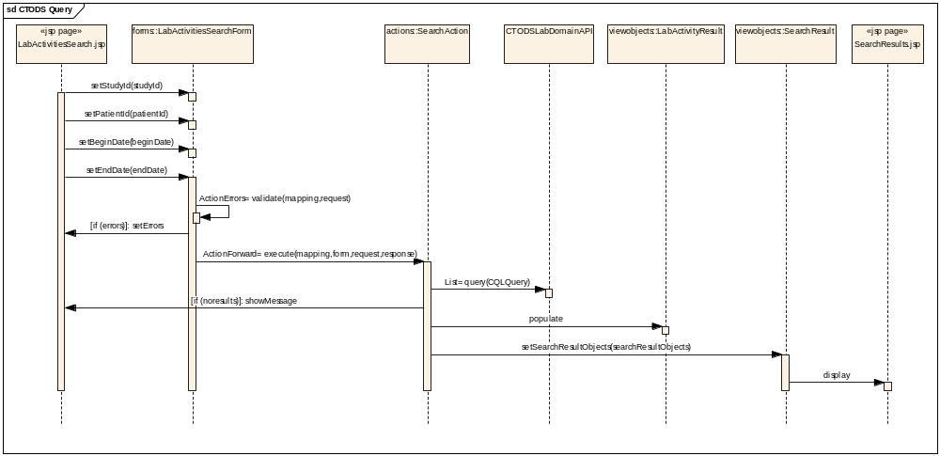

ASSUMPTIONS AND CONSTRAINTS:

Assumptions
The assumptions of the caXchange and it’s related software components are:
- The NCICB hosted components will be deployed in the shared production NCICB environment.
- The project components will adhere as closely as possible to the published NCICB Future Technology Stack
- The caCORE and caBIG products utilized in this solution are expected to perform their proposed functionality. If there are any product defects, they will be fixed by the respective product team and not the caXchange development team.
- If the appropriate versions of the proposed products that are expected to be used in this solution are not available, a work around must be implemented by the caXchange team, however, the caXchange team will not write replacements for those products.
- ServiceMix 3.1.1 (or 3.1.2) will be used for this caXchange release

Constraints
The dependencies of the caXchange and it’s related software components are described below:
- The caAdapter product will provide the user interface and the APIs to map and transform comma delimited patent lab data to an HL7v3 format.
- The C3PR grid service provided by C3PR V2 will be utilized to formulate the HL7v3 messages with additional study information.

System Specific Use Cases

CTODS Grid Services Use Case
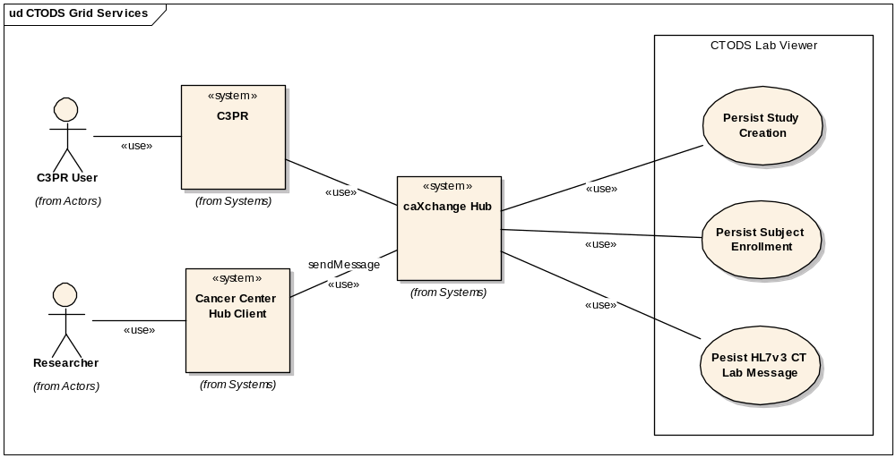
Figure 3 CTODS Grid Services Use Case Diagram

USE CASE DESCRIPTION
Use Case Name | Grid Services
Use Case ID | CTODScaXGS_1.0
Primary Actor | - C3PR Users  - Researcher
Secondary Actor | Not Defined
Brief Description | Send data packets from the C3PR and the Cancer Center Hub Client through the caXchange Hub to be viewed by the CTODS Lab Viewer
Trigger | Actor initiated
Pre-conditions | System and supporting components are operational and available
Primary Flow of Events | Message Persisted  - HL7v3 message is received  - Persist message to CTODS Store  - Return Success Status to client
Secondary Flow of Events | Message Persistence - Failed  - Message Store operation failed  - Generate a Fatal audit message indicating persistence failure  - Return "Failed" Status to client
Post Conditions | The correct data is viewed by authorized actors
Branch Point
Associated Quality Requirement(s)
Related Use Cases | CTODS Query
Business Rules

BASIC FLOW OF EVENTS:
The basic process flow of all the CTODS Grid Services is similar. The process is as follows:
- Receive Message from hub
- Validate the message is correct
- Check to verify that we have not already received this message
- Save the data in CTODS Lab Domain database with timestamp

Below we show the sequence diagrams for each of the individual grid services.

CTODS Create Study Sequence Diagram
The following diagram shows the sequence for the Create Study Grid Service which processes the study message that comes from C3PR via the hub. This also shows the condition where if another system is unable to process the study message then a rollback is issued from the hub to ensure that all systems are consistent.

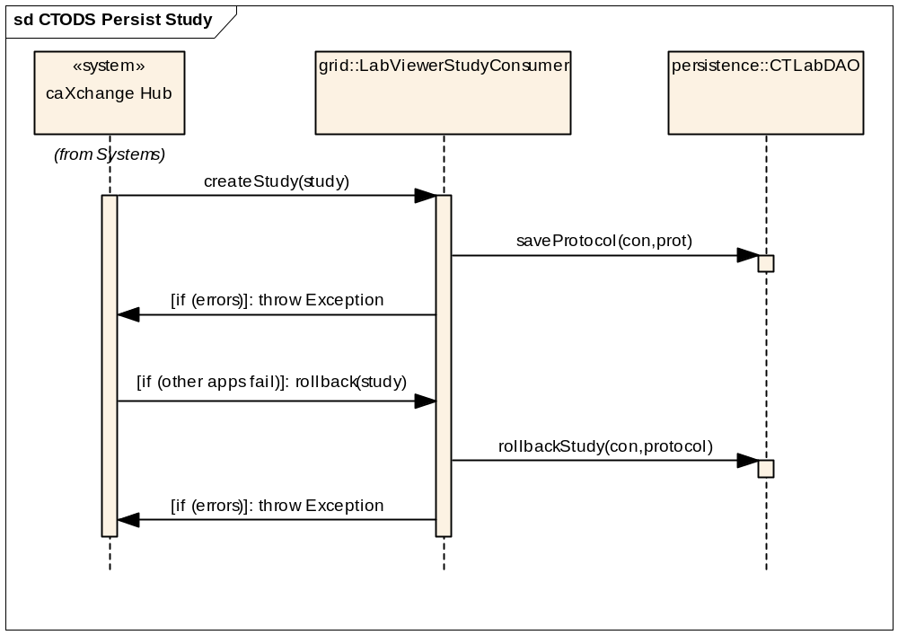
Figure 4 CTODS Create Study Grid Service Sequence Diagram

CTODS Register Patient Sequence Diagram
The following diagram shows the sequence for the Register Patient Grid Service which processes the patient registration message that comes from C3PR via the hub. This also shows the condition where if another system is unable to process the registration message then a rollback is issued from the hub to ensure that all systems are consistent.

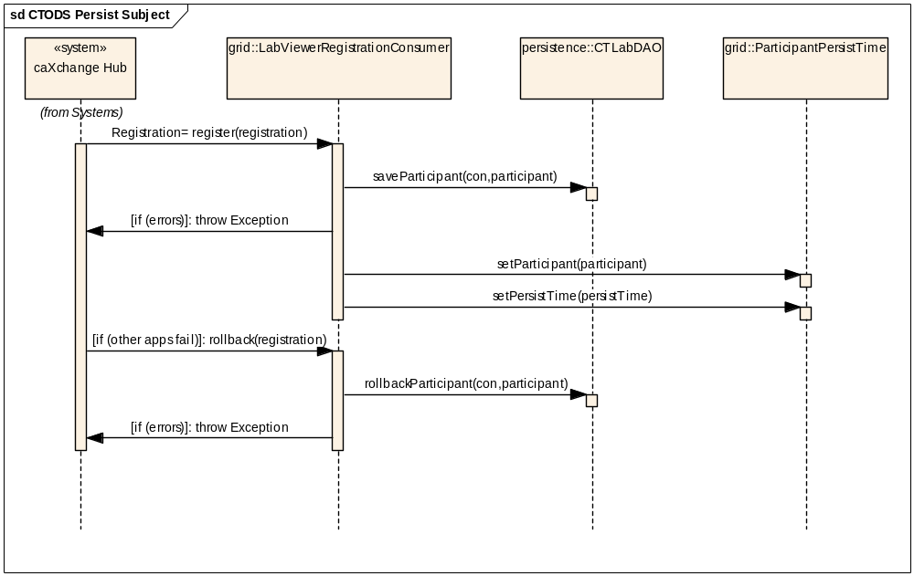
Figure 5 CTODS Patient Registration Grid Service Sequence Diagram

CTODS CT Lab Load Sequence Diagram
The following diagram shows the sequence for the CT Lab Load Grid Service which processes the HL7v3 Lab message that comes from the CCHC via the hub.

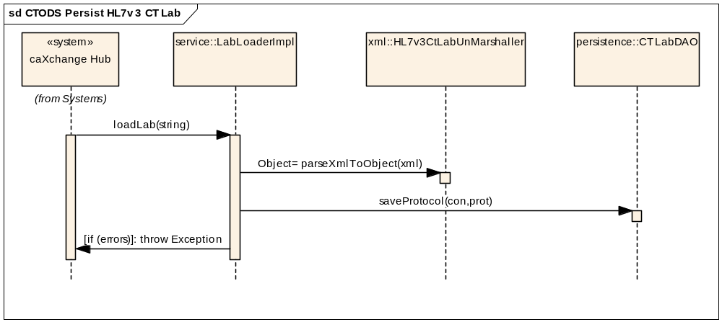
Figure 6 CTODS CT Lab Load Grid Service Sequence Diagram

ASSUMPTIONS AND CONSTRAINTS:

Assumptions
The assumptions of the caXchange and it’s related software components are:
- The NCICB hosted components will be deployed in the shared production NCICB environment.
- The project components will adhere as closely as possible to the published NCICB Future Technology Stack
- The caCORE and caBIG products utilized in this solution are expected to perform their proposed functionality. If there are any product defects, they will be fixed by the respective product team and not the caXchange development team.
- If the appropriate versions of the proposed products that are expected to be used in this solution are not available, a work around must be implemented by the caXchange team, however, the caXchange team will not write replacements for those products.
- ServiceMix 3.1.1 (or 3.1.2) will be used for this caXchange release

Constraints
The dependencies of the caXchange and it’s related software components are described below:
- The caAdapter product will provide the user interface and the APIs to map and transform comma delimited patent lab data to an HL7v3 format.
- The C3PR grid service provided by C3PR V2 will be utilized to formulate the HL7v3 messages with additional study information.

Use Case Change Management & Traceability

Overview
It is the responsibility of each CTODS Lab Viewer stakeholder to review and validate every element of application development within their purview. This Use Case document is a cornerstone to CTODS development and it is critical that this document be current and concise. In the event that a use case defined by this document is incorrect or requires revision, said correction, and/or revision should be forwarded to the CTODS Lab Viewer senior developer and/or architect in the form of a use case change request. The request should include specific information to be added or modified, a detailed explanation for the change, a through representation of the change, identification of the affected actors, and contributing stakeholders. The change request should also include the information necessary to complete the Change Management Tracking Matrices and the Use Case Traceability Matrices. The change request will be assigned a priority and will be incorporated as appropriate in reference to the assigned priority. Once included as document content, the relevant change request information will be added to the matrices.

Change Management Tracking Matrices
Priority | Use Case Name & ID | New/ Mod | Details | Approve/ Reject

Use Case Traceability Matrices
Use Case Name & ID | Details | Requirement Traceability

Overall Requirements

CTODS Grid Services
Req ID | Requirement Type | Requirement Details | Release # | Use Case ID
3.1 | System | The CTODS Data Service must receive messages in the HL7v3 CT Laboratory Observation Periodic Report format | 0.5 (Iteration 2) | Persist HL7v3 Message
3.2 | System | The CTODS Data Service must perform authentication and authorization security checks to ensure the sender is a recognized client and is authorized to send data to the CTODS data service | 0.5 (Iteration 2) | Persist HL7v3 Message
3.3 | System | The CTODS Data Service must persist the data from HL7v3 CT Laboratory Observation Periodic Report message to the CTODS database | 0.5 (Iteration 2) | Persist HL7v3 Message
3.4 | System | The CTODS Data Service will parse the HL7 v3 CT Laboratory Observation Periodic Report messages and persist only the domain related data into the CTODS database | 0.5 (Iteration 2) | Persist HL7v3 Message
3.5 | System | The CTODS Data Service will parse the C3PR Registration message and persist data pertaining to a participant if that participant exists within the CTODS database | CTMSI Project

CTODS Lab Viewer
Req ID | Requirement Type | Requirement Details | Release # | Use Case ID
6.1 | User | Users must be provided with a graphical user interface application to query and view the patient lab data from the CTODS database via the Lab domain APIs | CTMSI  Project
6.2 | User | Users must be able to login with a valid username and password. | CTMSI Project
6.3 | User | Users must be able to search for lab activities by patient identifier, study id, begin lab activity date, and end lab activity date. | CTMSI Project
6.4 | User | Users must be able to view the lab activity search results. | CTMSI Project
6.5 | User | Users must be able to select one or more lab activities from the search result and initiate a process to load them into an external CTMS system. | CTMSI Project
6.6 | User | Users must be able to initiate a process that flags a lab activity result as an Adverse Event and sends that lab activity to an external Adverse Event Reporting system. | CTMSI Project
6.7 | System | The system must be able to receive a link from an external system containing a valid GridProxy and search criteria. The link should login the user and pre-populate the search screen with the search criteria passed in the link. | CTMSI Project
6.7 | System | Integrate with Grid WebSSO such that a grid authenticated user can seamlessly navigate to and from CTODS labviewer based on grid credentials
6.8 | System | Integrate with Grid WebSSO for obtaining users authorization information to ensure that the user is allowed to perform certain operations

